Azure Cloud (Please register with Globant ID on Azure to avail free subscription and use effectively)

Assignment 1:

1. Create the Azure function app and azure web app using the ARM template and deploy using the Azure Cli command.

Create any prerequisites resources if required.

Deploy a sample Dot net application on the azure web app using CI/CD process.

Understand the use of Log analytics workspace.

shubham.sahu@IN-IT18554 azureFunction % az group create --name myResourceGroup --location eastus

{

"id": "/subscriptions/348cb6f0-e738-45ac-b6b0-7d830eaa9511/resourceGroups/myResourceGroup",

"location": "eastus",

"managedBy": null,

"name": "myResourceGroup",

"properties": {

"provisioningState": "Succeeded"

},

"tags": null,

"type": "Microsoft.Resources/resourceGroups"

}

shubham.sahu@IN-IT18554 azureFunction % az deployment group create \

--resource-group myResourceGroup \

--template-file azuredeploy.json \

--parameters appServicePlanName="myAppServicePlan" \

webAppName="my-dotnet-webapp-shubham123" \

functionAppName="my-functionapp-shubham123" \

storageAccountName="mystoredt1234shub" \

location="Central US"

{

"id": "/subscriptions/348cb6f0-e738-45ac-b6b0-7d830eaa9511/resourceGroups/myResourceGroup/providers/Microsoft.Resources/deployments/azuredeploy",

"location": null,

"name": "azuredeploy",

"properties": {

"correlationId": "949b4498-de34-446a-bd76-6f4e720233b8",

"debugSetting": null,

"dependencies": [

{

"dependsOn": [

{

"id": "/subscriptions/348cb6f0-e738-45ac-b6b0-7d830eaa9511/resourceGroups/myResourceGroup/providers/Microsoft.Web/serverfarms/myAppServicePlan",

"resourceGroup": "myResourceGroup",

"resourceName": "myAppServicePlan",

"resourceType": "Microsoft.Web/serverfarms"

}

],

"id": "/subscriptions/348cb6f0-e738-45ac-b6b0-7d830eaa9511/resourceGroups/myResourceGroup/providers/Microsoft.Web/sites/my-dotnet-webapp-shubham123",

"resourceGroup": "myResourceGroup",

"resourceName": "my-dotnet-webapp-shubham123",

"resourceType": "Microsoft.Web/sites"

},

{

"dependsOn": [

{

"id": "/subscriptions/348cb6f0-e738-45ac-b6b0-7d830eaa9511/resourceGroups/myResourceGroup/providers/Microsoft.Web/serverfarms/functionAppPlan",

"resourceGroup": "myResourceGroup",

"resourceName": "functionAppPlan",

"resourceType": "Microsoft.Web/serverfarms"

},

{

"id": "/subscriptions/348cb6f0-e738-45ac-b6b0-7d830eaa9511/resourceGroups/myResourceGroup/providers/Microsoft.Storage/storageAccounts/mystoredt1234shub",

"resourceGroup": "myResourceGroup",

"resourceName": "mystoredt1234shub",

"resourceType": "Microsoft.Storage/storageAccounts"

},

{

"actionName": "listKeys",

"apiVersion": "2022-05-01",

"id": "/subscriptions/348cb6f0-e738-45ac-b6b0-7d830eaa9511/resourceGroups/myResourceGroup/providers/Microsoft.Storage/storageAccounts/mystoredt1234shub",

"resourceGroup": "myResourceGroup",

"resourceName": "mystoredt1234shub",

"resourceType": "Microsoft.Storage/storageAccounts"

}

],

"id": "/subscriptions/348cb6f0-e738-45ac-b6b0-7d830eaa9511/resourceGroups/myResourceGroup/providers/Microsoft.Web/sites/my-functionapp-shubham123",

"resourceGroup": "myResourceGroup",

"resourceName": "my-functionapp-shubham123",

"resourceType": "Microsoft.Web/sites"

}

],

"duration": "PT56.4581297S",

"error": null,

"mode": "Incremental",

"onErrorDeployment": null,

"outputResources": [

{

"id": "/subscriptions/348cb6f0-e738-45ac-b6b0-7d830eaa9511/resourceGroups/myResourceGroup/providers/Microsoft.Storage/storageAccounts/mystoredt1234shub",

"resourceGroup": "myResourceGroup"

},

{

"id": "/subscriptions/348cb6f0-e738-45ac-b6b0-7d830eaa9511/resourceGroups/myResourceGroup/providers/Microsoft.Web/serverfarms/functionAppPlan",

"resourceGroup": "myResourceGroup"

},

{

"id": "/subscriptions/348cb6f0-e738-45ac-b6b0-7d830eaa9511/resourceGroups/myResourceGroup/providers/Microsoft.Web/serverfarms/myAppServicePlan",

"resourceGroup": "myResourceGroup"

},

{

"id": "/subscriptions/348cb6f0-e738-45ac-b6b0-7d830eaa9511/resourceGroups/myResourceGroup/providers/Microsoft.Web/sites/my-dotnet-webapp-shubham123",

"resourceGroup": "myResourceGroup"

},

{

"id": "/subscriptions/348cb6f0-e738-45ac-b6b0-7d830eaa9511/resourceGroups/myResourceGroup/providers/Microsoft.Web/sites/my-functionapp-shubham123",

"resourceGroup": "myResourceGroup"

}

],

"outputs": {

"functionAppUrl": {

"type": "String",

"value": "https://my-functionapp-shubham123.azurewebsites.net"

},

"webAppUrl": {

"type": "String",

"value": "https://my-dotnet-webapp-shubham123.azurewebsites.net"

}

},

"parameters": {

"appServicePlanName": {

"type": "String",

"value": "myAppServicePlan"

},

"functionAppName": {

"type": "String",

"value": "my-functionapp-shubham123"

},

"location": {

"type": "String",

"value": "Central US"

},

"storageAccountName": {

"type": "String",

"value": "mystoredt1234shub"

},

"webAppName": {

"type": "String",

"value": "my-dotnet-webapp-shubham123"

}

},

"parametersLink": null,

"providers": [

{

"id": null,

"namespace": "Microsoft.Web",

"providerAuthorizationConsentState": null,

"registrationPolicy": null,

"registrationState": null,

"resourceTypes": [

{

"aliases": null,

"apiProfiles": null,

"apiVersions": null,

"capabilities": null,

"defaultApiVersion": null,

"locationMappings": null,

"locations": [

"centralus"

],

"properties": null,

"resourceType": "serverfarms",

"zoneMappings": null

},

{

"aliases": null,

"apiProfiles": null,

"apiVersions": null,

"capabilities": null,

"defaultApiVersion": null,

"locationMappings": null,

"locations": [

"centralus"

],

"properties": null,

"resourceType": "sites",

"zoneMappings": null

}

]

},

{

"id": null,

"namespace": "Microsoft.Storage",

"providerAuthorizationConsentState": null,

"registrationPolicy": null,

"registrationState": null,

"resourceTypes": [

{

"aliases": null,

"apiProfiles": null,

"apiVersions": null,

"capabilities": null,

"defaultApiVersion": null,

"locationMappings": null,

"locations": [

"centralus"

],

"properties": null,

"resourceType": "storageAccounts",

"zoneMappings": null

}

]

}

],

"provisioningState": "Succeeded",

"templateHash": "13138500127844175004",

"templateLink": null,

"timestamp": "2025-05-15T06:13:23.325908+00:00",

"validatedResources": null

},

"resourceGroup": "myResourceGroup",

"tags": null,

"type": "Microsoft.Resources/deployments"

}

shubham.sahu@IN-IT18554 azureFunction % >.

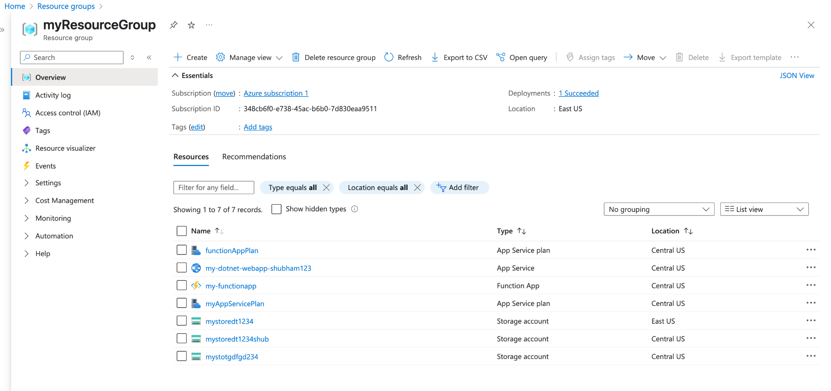

Application deployment done:

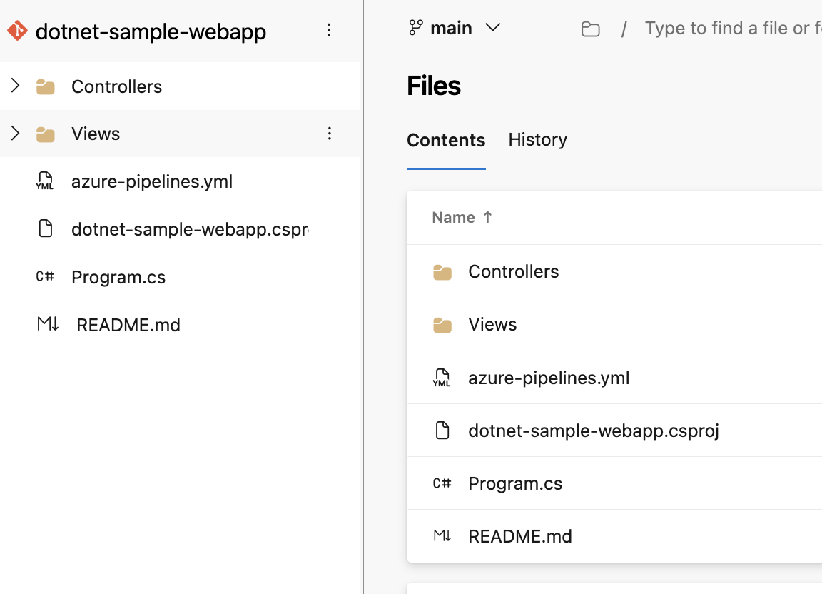

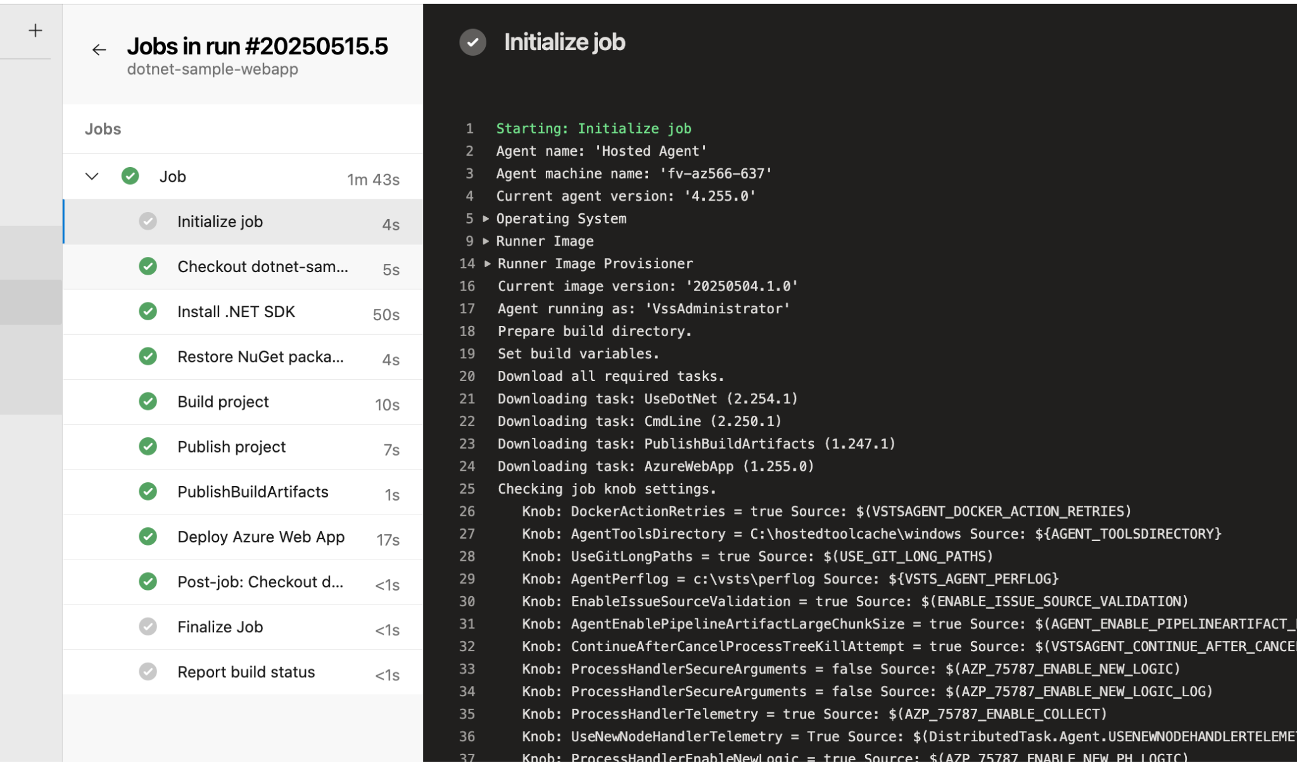

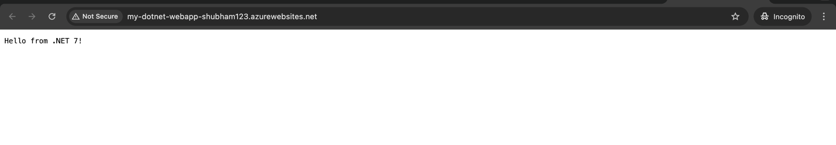

**Understand and Use Log Analytics Workspace**

Log Analytics is part of Azure Monitor. It collects and analyzes logs from your resources.

Create Log Analytics Workspace

az monitor log-analytics workspace create \

--resource-group myResourceGroup \

--workspace-name myLogAnalytics \

--location eastus

Assignment 2:

1. Create a simple Azure infrastructure that leverages Azure Managed Identity to securely access an Azure Key Vault from an Azure Function App.

shubham.sahu@IN-IT18554 azureFunctionTask2 % az deployment group create \

--resource-group myResourceGroup \

--template-file azuredeploy.json \

--parameters @azuredeploy.parameters.json

{

"id": "/subscriptions/348cb6f0-e738-45ac-b6b0-7d830eaa9511/resourceGroups/myResourceGroup/providers/Microsoft.Resources/deployments/azuredeploy",

"location": null,

"name": "azuredeploy",

"properties": {

"correlationId": "56b1dee9-442c-483d-936b-20cd2d819691",

"debugSetting": null,

"dependencies": [

{

"dependsOn": [

{

"id": "/subscriptions/348cb6f0-e738-45ac-b6b0-7d830eaa9511/resourceGroups/myResourceGroup/providers/Microsoft.Web/serverfarms/shub-webapp-plan",

"resourceGroup": "myResourceGroup",

"resourceName": "shub-webapp-plan",

"resourceType": "Microsoft.Web/serverfarms"

}

],

"id": "/subscriptions/348cb6f0-e738-45ac-b6b0-7d830eaa9511/resourceGroups/myResourceGroup/providers/Microsoft.Web/sites/shub-dotnet-webapp",

"resourceGroup": "myResourceGroup",

"resourceName": "shub-dotnet-webapp",

"resourceType": "Microsoft.Web/sites"

},

{

"dependsOn": [

{

"id": "/subscriptions/348cb6f0-e738-45ac-b6b0-7d830eaa9511/resourceGroups/myResourceGroup/providers/Microsoft.Web/serverfarms/shub-funcapp-plan",

"resourceGroup": "myResourceGroup",

"resourceName": "shub-funcapp-plan",

"resourceType": "Microsoft.Web/serverfarms"

},

{

"id": "/subscriptions/348cb6f0-e738-45ac-b6b0-7d830eaa9511/resourceGroups/myResourceGroup/providers/Microsoft.Storage/storageAccounts/shubstorageacct123",

"resourceGroup": "myResourceGroup",

"resourceName": "shubstorageacct123",

"resourceType": "Microsoft.Storage/storageAccounts"

},

{

"actionName": "listKeys",

"apiVersion": "2022-09-01",

"id": "/subscriptions/348cb6f0-e738-45ac-b6b0-7d830eaa9511/resourceGroups/myResourceGroup/providers/Microsoft.Storage/storageAccounts/shubstorageacct123",

"resourceGroup": "myResourceGroup",

"resourceName": "shubstorageacct123",

"resourceType": "Microsoft.Storage/storageAccounts"

}

],

"id": "/subscriptions/348cb6f0-e738-45ac-b6b0-7d830eaa9511/resourceGroups/myResourceGroup/providers/Microsoft.Web/sites/shub-funcapp",

"resourceGroup": "myResourceGroup",

"resourceName": "shub-funcapp",

"resourceType": "Microsoft.Web/sites"

}

],

"duration": "PT58.8605769S",

"error": null,

"mode": "Incremental",

"onErrorDeployment": null,

"outputResources": [

{

"id": "/subscriptions/348cb6f0-e738-45ac-b6b0-7d830eaa9511/resourceGroups/myResourceGroup/providers/Microsoft.KeyVault/vaults/shub-keyvault",

"resourceGroup": "myResourceGroup"

},

{

"id": "/subscriptions/348cb6f0-e738-45ac-b6b0-7d830eaa9511/resourceGroups/myResourceGroup/providers/Microsoft.Storage/storageAccounts/shubstorageacct123",

"resourceGroup": "myResourceGroup"

},

{

"id": "/subscriptions/348cb6f0-e738-45ac-b6b0-7d830eaa9511/resourceGroups/myResourceGroup/providers/Microsoft.Web/serverfarms/shub-funcapp-plan",

"resourceGroup": "myResourceGroup"

},

{

"id": "/subscriptions/348cb6f0-e738-45ac-b6b0-7d830eaa9511/resourceGroups/myResourceGroup/providers/Microsoft.Web/serverfarms/shub-webapp-plan",

"resourceGroup": "myResourceGroup"

},

{

"id": "/subscriptions/348cb6f0-e738-45ac-b6b0-7d830eaa9511/resourceGroups/myResourceGroup/providers/Microsoft.Web/sites/shub-dotnet-webapp",

"resourceGroup": "myResourceGroup"

},

{

"id": "/subscriptions/348cb6f0-e738-45ac-b6b0-7d830eaa9511/resourceGroups/myResourceGroup/providers/Microsoft.Web/sites/shub-funcapp",

"resourceGroup": "myResourceGroup"

}

],

"outputs": null,

"parameters": {

"appServicePlanName": {

"type": "String",

"value": "shub-webapp-plan"

},

"functionAppHostingPlanName": {

"type": "String",

"value": "shub-funcapp-plan"

},

"functionAppName": {

"type": "String",

"value": "shub-funcapp"

},

"keyVaultName": {

"type": "String",

"value": "shub-keyvault"

},

"location": {

"type": "String",

"value": "Central US"

},

"storageAccountName": {

"type": "String",

"value": "shubstorageacct123"

},

"webAppName": {

"type": "String",

"value": "shub-dotnet-webapp"

}

},

"parametersLink": null,

"providers": [

{

"id": null,

"namespace": "Microsoft.Storage",

"providerAuthorizationConsentState": null,

"registrationPolicy": null,

"registrationState": null,

"resourceTypes": [

{

"aliases": null,

"apiProfiles": null,

"apiVersions": null,

"capabilities": null,

"defaultApiVersion": null,

"locationMappings": null,

"locations": [

"centralus"

],

"properties": null,

"resourceType": "storageAccounts",

"zoneMappings": null

}

]

},

{

"id": null,

"namespace": "Microsoft.Web",

"providerAuthorizationConsentState": null,

"registrationPolicy": null,

"registrationState": null,

"resourceTypes": [

{

"aliases": null,

"apiProfiles": null,

"apiVersions": null,

"capabilities": null,

"defaultApiVersion": null,

"locationMappings": null,

"locations": [

"centralus"

],

"properties": null,

"resourceType": "serverfarms",

"zoneMappings": null

},

{

"aliases": null,

"apiProfiles": null,

"apiVersions": null,

"capabilities": null,

"defaultApiVersion": null,

"locationMappings": null,

"locations": [

"centralus"

],

"properties": null,

"resourceType": "sites",

"zoneMappings": null

}

]

},

{

"id": null,

"namespace": "Microsoft.KeyVault",

"providerAuthorizationConsentState": null,

"registrationPolicy": null,

"registrationState": null,

"resourceTypes": [

{

"aliases": null,

"apiProfiles": null,

"apiVersions": null,

"capabilities": null,

"defaultApiVersion": null,

"locationMappings": null,

"locations": [

"centralus"

],

"properties": null,

"resourceType": "vaults",

"zoneMappings": null

}

]

}

],

"provisioningState": "Succeeded",

"templateHash": "6571038593526523128",

"templateLink": null,

"timestamp": "2025-05-15T09:51:06.034769+00:00",

"validatedResources": null

},

"resourceGroup": "myResourceGroup",

"tags": null,

"type": "Microsoft.Resources/deployments"

}

shubham.sahu@IN-IT18554 azureFunctionTask2 %

Enable Managed Identity for the Azure Function App:

You need to enable the managed identity for your Azure Function App.

shubham.sahu@IN-IT18554 azureFunctionTask2 % az functionapp identity assign --name shub-funcapp --resource-group MyResourceGroup

{

"principalId": "9fa98fb9-4d9d-4dcc-a047-ee0c4dca5ed1",

"tenantId": "b9cfd1a1-0770-4666-a62a-9f37563d7b6b",

"type": "SystemAssigned",

"userAssignedIdentities": null

}

shubham.sahu@IN-IT18554 azureFunctionTask2 %

shubham.sahu@IN-IT18554 azureFunctionTask2 % az keyvault set-policy --name shub-keyvault --object-id 9fa98fb9-4d9d-4dcc-a047-ee0c4dca5ed1 --secret-permissions get

{

"id": "/subscriptions/348cb6f0-e738-45ac-b6b0-7d830eaa9511/resourceGroups/myResourceGroup/providers/Microsoft.KeyVault/vaults/shub-keyvault",

"location": "Central US",

"name": "shub-keyvault",

"properties": {

"accessPolicies": [

{

"applicationId": null,

"objectId": "9fa98fb9-4d9d-4dcc-a047-ee0c4dca5ed1",

"permissions": {

"certificates": null,

"keys": null,

"secrets": [

"get"

],

"storage": null

},

"tenantId": "b9cfd1a1-0770-4666-a62a-9f37563d7b6b"

}

],

"createMode": null,

"enablePurgeProtection": null,

"enableRbacAuthorization": null,

"enableSoftDelete": true,

"enabledForDeployment": false,

"enabledForDiskEncryption": null,

"enabledForTemplateDeployment": null,

"hsmPoolResourceId": null,

"networkAcls": null,

"privateEndpointConnections": null,

"provisioningState": "Succeeded",

"publicNetworkAccess": "Enabled",

"sku": {

"family": "A",

"name": "standard"

},

"softDeleteRetentionInDays": null,

"tenantId": "b9cfd1a1-0770-4666-a62a-9f37563d7b6b",

"vaultUri": "https://shub-keyvault.vault.azure.net/"

},

"resourceGroup": "myResourceGroup",

"systemData": {

"createdAt": "2025-05-15T09:50:17.248000+00:00",

"createdBy": "bhagyashree.gupta94@gmail.com",

"createdByType": "User",

"lastModifiedAt": "2025-05-15T12:54:09.545000+00:00",

"lastModifiedBy": "bhagyashree.gupta94@gmail.com",

"lastModifiedByType": "User"

},

"tags": {},

"type": "Microsoft.KeyVault/vaults"

}

Assign Permissions for Key Vault Access

Once you have the principalId, you can assign permissions to the Function App's managed identity to access secrets in your Azure Key Vault.

az keyvault set-policy --name MyKeyVault --object-id <principalId> --secret-permissions get

shubham.sahu@IN-IT18554 azureFunctionTask2 % az keyvault set-policy --name shub-keyvault --object-id 9fa98fb9-4d9d-4dcc-a047-ee0c4dca5ed1 --secret-permissions get

{

"id": "/subscriptions/348cb6f0-e738-45ac-b6b0-7d830eaa9511/resourceGroups/myResourceGroup/providers/Microsoft.KeyVault/vaults/shub-keyvault",

"location": "Central US",

"name": "shub-keyvault",

"properties": {

"accessPolicies": [

{

"applicationId": null,

"objectId": "9fa98fb9-4d9d-4dcc-a047-ee0c4dca5ed1",

"permissions": {

"certificates": null,

"keys": null,

"secrets": [

"get"

],

"storage": null

},

"tenantId": "b9cfd1a1-0770-4666-a62a-9f37563d7b6b"

}

],

"createMode": null,

"enablePurgeProtection": null,

"enableRbacAuthorization": null,

"enableSoftDelete": true,

"enabledForDeployment": false,

"enabledForDiskEncryption": null,

"enabledForTemplateDeployment": null,

"hsmPoolResourceId": null,

"networkAcls": null,

"privateEndpointConnections": null,

"provisioningState": "Succeeded",

"publicNetworkAccess": "Enabled",

"sku": {

"family": "A",

"name": "standard"

},

"softDeleteRetentionInDays": null,

"tenantId": "b9cfd1a1-0770-4666-a62a-9f37563d7b6b",

"vaultUri": "https://shub-keyvault.vault.azure.net/"

},

"resourceGroup": "myResourceGroup",

"systemData": {

"createdAt": "2025-05-15T09:50:17.248000+00:00",

"createdBy": "bhagyashree.gupta94@gmail.com",

"createdByType": "User",

"lastModifiedAt": "2025-05-15T12:54:09.545000+00:00",

"lastModifiedBy": "bhagyashree.gupta94@gmail.com",

"lastModifiedByType": "User"

},

"tags": {},

"type": "Microsoft.KeyVault/vaults"

}

### Verify Permissions

Once you’ve run the command the managed identity should now have the appropriate permissions to access secrets in your Key Vault

shubham.sahu@IN-IT18554 azureFunctionTask2 % az keyvault show --name shub-keyvault --query "properties.accessPolicies"

[

{

"applicationId": null,

"objectId": "9fa98fb9-4d9d-4dcc-a047-ee0c4dca5ed1",

"permissions": {

"certificates": null,

"keys": null,

"secrets": [

"get"

],

"storage": null

},

"tenantId": "b9cfd1a1-0770-4666-a62a-9f37563d7b6b"

}

]

shubham.sahu@IN-IT18554 azureFunctionTask2 %

Assignment 3:

1. Create an Azure Application Registration, configure it with appropriate permissions, and demonstrate how to use it to authenticate and authorize access to Azure resources.

Step 1: Create an Azure Application Registration   
  
az ad app create --display-name "MyAppRegistration"

Step 2: Create Service Principal for the Application

SP_ID=$(az ad sp create --id $(az ad app list --display-name "MyAppRegistration" --query '[0].appId' -o tsv))

Step 3: Output the Service Principal ID

echo "Service Principal ID: $SP_ID"

Assign Permissions

After you've created the service principal, you can assign it a role (e.g., Contributor) to a specific Azure resource group:

az role assignment create --assignee $SP_ID --role Contributor --scope /subscriptions/{subscriptionId}/resourceGroups/myResourceGroup

Verify Role Assignment

After assigning the role, you can verify the role assignment by running:

az role assignment list --assignee $SP_ID --output table

az ad app create --display-name "MyAppRegistration"

shubham.sahu@IN-IT18554 azureFunctionTask2 % az ad app create --display-name "MyAppRegistration"

{

"@odata.context": "https://graph.microsoft.com/v1.0/$metadata#applications/$entity",

"addIns": [],

"api": {

"acceptMappedClaims": null,

"knownClientApplications": [],

"oauth2PermissionScopes": [],

"preAuthorizedApplications": [],

"requestedAccessTokenVersion": null

},

"appId": "e220b6cb-aad3-4939-9a1d-6bde091324e8",

"appRoles": [],

"applicationTemplateId": null,

"certification": null,

"createdDateTime": "2025-05-16T10:30:43.5254037Z",

"defaultRedirectUri": null,

"deletedDateTime": null,

"description": null,

"disabledByMicrosoftStatus": null,

"displayName": "MyAppRegistration",

"groupMembershipClaims": null,

"id": "952b8436-3884-4fd2-833d-b33d8677eceb",

"identifierUris": [],

"info": {

"logoUrl": null,

"marketingUrl": null,

"privacyStatementUrl": null,

"supportUrl": null,

"termsOfServiceUrl": null

},

"isDeviceOnlyAuthSupported": null,

"isFallbackPublicClient": null,

"keyCredentials": [],

"nativeAuthenticationApisEnabled": null,

"notes": null,

"optionalClaims": null,

"parentalControlSettings": {

"countriesBlockedForMinors": [],

"legalAgeGroupRule": "Allow"

},

"passwordCredentials": [],

"publicClient": {

"redirectUris": []

},

"publisherDomain": "bhagyashreegupta94gmail.onmicrosoft.com",

"requestSignatureVerification": null,

"requiredResourceAccess": [],

"samlMetadataUrl": null,

"serviceManagementReference": null,

"servicePrincipalLockConfiguration": null,

"signInAudience": "AzureADMyOrg",

"spa": {

"redirectUris": []

},

"tags": [],

"tokenEncryptionKeyId": null,

"uniqueName": null,

"verifiedPublisher": {

"addedDateTime": null,

"displayName": null,

"verifiedPublisherId": null

},

"web": {

"homePageUrl": null,

"implicitGrantSettings": {

"enableAccessTokenIssuance": false,

"enableIdTokenIssuance": false

},

"logoutUrl": null,

"redirectUriSettings": [],

"redirectUris": []

}

}

​​

shubham.sahu@IN-IT18554 azureFunctionTask2 % SP_ID=$(az ad sp create --id $(az ad app list --display-name "MyAppRegistration" --query '[0].appId' -o tsv))

echo "Service Principal ID:

dquote>

dquote>

shubham.sahu@IN-IT18554 azureFunctionTask2 %

shubham.sahu@IN-IT18554 azureFunctionTask2 %

shubham.sahu@IN-IT18554 azureFunctionTask2 %

shubham.sahu@IN-IT18554 azureFunctionTask2 % SP_ID=$(az ad sp create --id $(az ad app list --display-name "MyAppRegistration" --query '[0].appId' -o tsv))

shubham.sahu@IN-IT18554 azureFunctionTask2 % echo "Service Principal ID: $SP_ID"

Service Principal ID: {

"@odata.context": "https://graph.microsoft.com/v1.0/$metadata#servicePrincipals/$entity",

"accountEnabled": true,

"addIns": [],

"alternativeNames": [],

"appDescription": null,

"appDisplayName": "MyAppRegistration",

"appId": "e220b6cb-aad3-4939-9a1d-6bde091324e8",

"appOwnerOrganizationId": "b9cfd1a1-0770-4666-a62a-9f37563d7b6b",

"appRoleAssignmentRequired": false,

"appRoles": [],

"applicationTemplateId": null,

"createdDateTime": null,

"deletedDateTime": null,

"description": null,

"disabledByMicrosoftStatus": null,

"displayName": "MyAppRegistration",

"homepage": null,

"id": "925002f8-829e-43b7-987f-aad543908f6f",

"info": {

"logoUrl": null,

"marketingUrl": null,

"privacyStatementUrl": null,

"supportUrl": null,

"termsOfServiceUrl": null

},

"keyCredentials": [],

"loginUrl": null,

"logoutUrl": null,

"notes": null,

"notificationEmailAddresses": [],

"oauth2PermissionScopes": [],

"passwordCredentials": [],

"preferredSingleSignOnMode": null,

"preferredTokenSigningKeyThumbprint": null,

"replyUrls": [],

"resourceSpecificApplicationPermissions": [],

"samlSingleSignOnSettings": null,

"servicePrincipalNames": [

"e220b6cb-aad3-4939-9a1d-6bde091324e8"

],

"servicePrincipalType": "Application",

"signInAudience": "AzureADMyOrg",

"tags": [],

"tokenEncryptionKeyId": null,

"verifiedPublisher": {

"addedDateTime": null,

"displayName": null,

"verifiedPublisherId": null

}

}